**PROBLEM – 4** List the event requests with a status of “Approved” or “Denied” and an authorized date in July 2018. Include the event number, authorization date, and status in the output. (Hint: see the examples in Module 4 for date constants in Oracle and MySQL.)

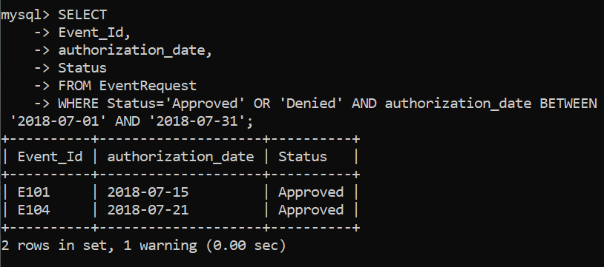

**SELECT**

**-> Event_Id,**

**-> authorization_date,**

**-> Status**

**-> FROM EventRequest**

**-> WHERE Status='Approved' OR 'Denied' AND authorization_date BETWEEN '2018-07-01' AND '2018-07-31';**